PRELIMINARY TASK

4TH MODULE



Faculty of Informatics

Telkom University

Bandung

# Preliminary Task Rules

This PT is **MANDATORY.**

* Every question have to be answered, **skipped one question ? PT Score = 0**
* PT should be **HANDWRITTEN** on your Preliminary Task Book, with requirements : B5 book size, with the standart cover. **If you writing is not complete, then your PT score will get a 50% discount.**
* You have to complete and put your PT before **19 February 2018, 06.30 IFLAB’**s TIME to the designated locker for each classroom.
* Asisten tidak bertanggung jawab terhadap TP yang tidak berada pada tempat yang ditentukan sebelumnya.
* Should you be late on your assignment, your journal grade will be **reduced by 50%. and your PT SCORE = 0.**
* **Not doing PT ? PT Score = 0, Pre-Test = 0**
* Do your PT as concise and clear as possible.
* Multiple choices question is answered by the format : **Question - Answer**
* Every question that needs to be answered with a program, **attach the screenshot of the source code and the output.**
* Screenshot **MUST** be attached to your paper with a **GLUE** (**Staples are not allowed)** Screenshot **Wajib** ditempel (tidak boleh di hekter). Assistants are not responsible if the attached paper have gone.
* Every question that needs to be programmed, **the question does not need to be written**.
* every selector in your css or javascript has to have your NIM

example : .button_1301161234

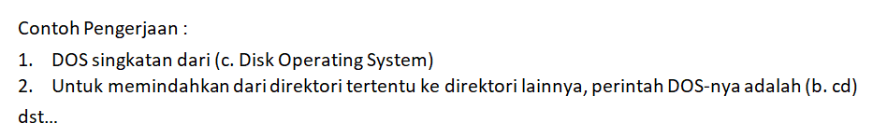

**1.** Make a simple calculator application using jQuery. Every calculator function (+, -, *, /) is made with a separate function (ex: function plus() {}). Try to answer it yourself ( dont copy and paste from website) and using plugins is not allowed.

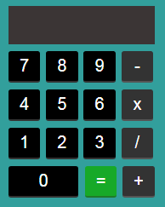

**2.** Make a form that looks like the image below.

a. Make a jQuery function that when the button “Simpan” is clicked, then the value of the form will add a record on the table.

b. Make a jQuery function that when the button “Hapus” is clicked, then the record on the table will be deleted. Use a confirmation popup (yes/no) to confirm whether that record wants to be deleted or not. (see image)

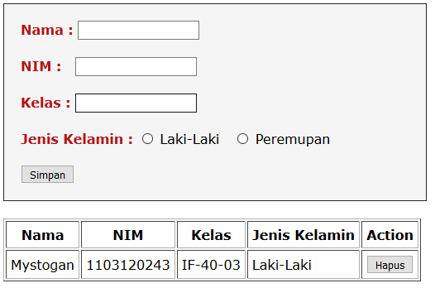

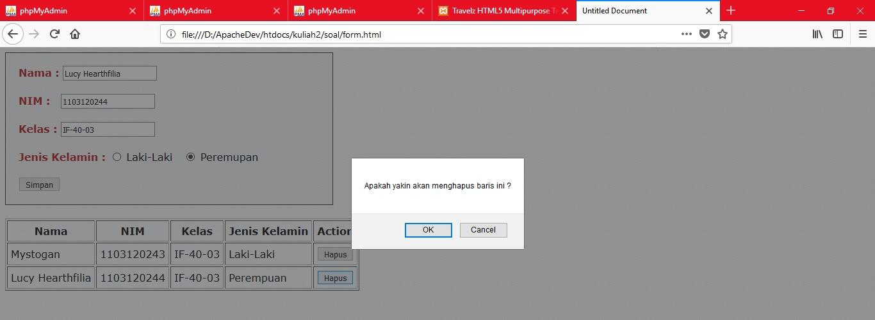

**3.** Make it like the image below. Then make a jQuery function, when button “A”, “B”, “C”, ... , “Z” is pushed**,** it will display three animal with its initial name the same as the button pressed(see image). When a button is pressed then the color will change to red with white text (see image). Make this in a 3 shape, pay attention to these requirements :

1. Use **div** in each of the animal name, then use function **show()** and **hide()** to display the name of the animal. Example :

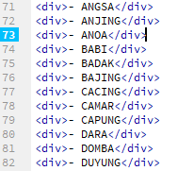

b. Use array to save the animal name. Then display the animal name.

c. Use **JSON** format in separate file (file **.json)** to save the animal name. Then use the **ajax()** function to call the .json file and read the content of that JSON file. Afterward, display the name of the animal.

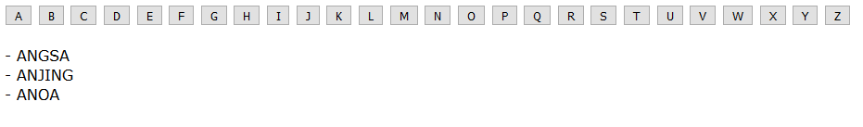

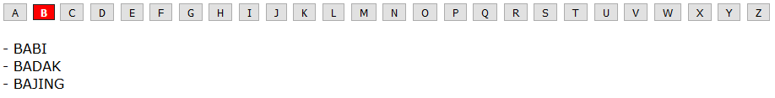

**4.** Make a web that will look like the one below.

Make a jQuery function for the 6 button in that display to make the car move move forward and backward. Then when the car hit the red line, the car will stop moving. Details :

* Maju 10 Pixel : Car will move 10 pixel.
* Maju 1 Langkah : Car will move exactly as the width of the car image
* Maju 2 langkah : Car will move exactly twice the width of the car image
* Mundur 10 Pixel : Car will move backward 10 pixel.
* Mundur 1 Langkah : Car will move backward exactly as the width of the car image
* Mundur 2 Langkah : Car will move backward exactly twice the width of the car image.

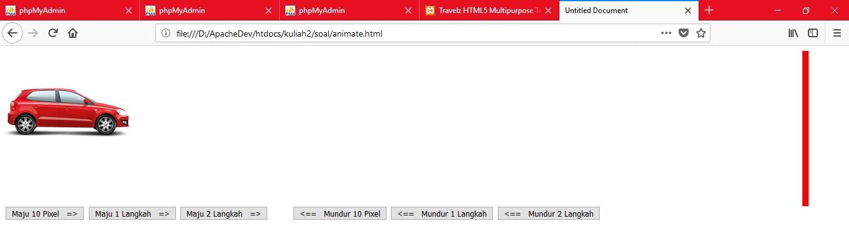

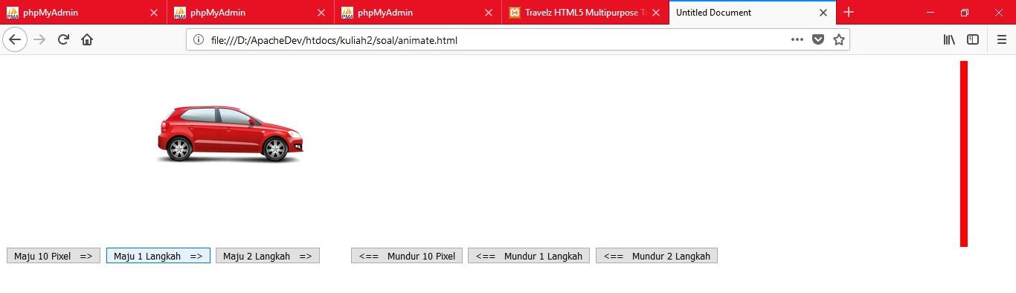

Link image: <http://www.free-icons-download.net/images/car-icon-13955.png>



WEB PROGRAMMING ASSISTANT

CONTACT PERSON 2017 / 2018

**Please contact your assistant below if you need further help regarding preliminary task or web pro material.**

|  |  |  |
| --- | --- | --- |
| No | Nama | ID LINE |
| 1 | Rama Aditya Maulana | ramaadtym |
| 2 | Rais Hafiyyan | raishafiyyan |
| 3 | Ibnu Agiel Althur | kingalthur |
| 4 | Brama Hendra | bramahendramahendra1 |
| 5 | Imam Ali Nurdin | alinurdinn |
| 6 | Ikke Dian | ikkedianokt |
| 7 | Desanty Ridzky | desantyr |
| 8 | Afnizar Nur Ghifari | afnizarnur |
| 9 | Dhia Imtinan Intar | zyx1124 |
| 10 | Daniel Tanta Christopher | danielmancity |
| 11 | Mochammad Naofal | mochamadnaofal |
| 12 | Fakhri Fauzan | fakhrifauzan |
| 13 | Dias Pambudi Satria | dias_pambudi |
| 14 | Hanif Salafi | salafihanif |
| 15 | Givanni Trisya Putri | givannitrisya |
| 16 | Kukuh sanddi razaq | kukuhs |
| 17 | Ainun N | ainundekain |
| 18 | Kukuh Sulistiyo | kukuh.sulistyo |
| 19 | Abdul Rahman Safari | arahsafari |
| 20 | Gomgom H. Panggabean | godvestoria |
| 21 | Krisna Adi Thama | krisna_at |
| 22 | M. Irwan Afandi | irwan_afandi.  (pakai titik) |
| 23 | Faza Ghassani | Oranyeu |
| 24 | Febri Ghaisani | febry.ghaisani |
| 25 | Kamal Mahmud | kamalhm |